**Take Home Program 4 - Due on or before midnight of Sunday October 7**

**Objective:** Structures and Functions

|  |
| --- |
| **Important instructions:**   * *All programs must include comments at the top of your program: your name, course name-section number (e.g. CSIT 839 -26953), program name and the program description in brief.* * *Copy and paste your program code and outputs in Part B of each program.* * *Once it is done, save and submit this word file via Canvas.* |

**1. TravelTime.cpp**

Write a program that uses a structure named **TravelTime** to store hours and minutes.

**struct TravelTime**

**{**

**int hours;**

**int minutes;**

**}**

The program prompts the user to enter hours and minutes for day1 and day2.

The **sum** function will calculate the total hours and minutes of two-day travel and the **show_time** function will display hours and minutes for two-day travel.

Day 3 travel time is given as **TravelTime day3 = {5, 56};**

The program will calculate three-day travel and display on the screen.

**Sample Output:**

*** Day 1 Travel

Enter hours for day 1: 15

Enter minutes for day 1: 75

*** Day 2 Travel

Enter hours for day 2: 13

Enter minutes for day 2: 45

Your trip summary for two-day total: 30 hours, 0 minutes

*** Day 3 Travel (Given) 5 and 56 minutes.

And now, the total of your three-day travel: 35 hours, 56 minutes

**Given function prototypes**

TravelTime sum(TravelTime t1, TravelTime t2);

void show_time(TravelTime t);

**Copy and paste your program (source) code and the outputs after this line**

**+++++++++++++++++++++++++++++++++++++++++++++++++**

/*

TravelTime.cpp

Inola Cohen

CSIT 839 - 26953

Purpose: to prompt user

to enter hours and minutes for 2 days

and use a structure to store hours

and minutes

*/

//#include “stdafx.h”

#include <iostream>

using namespace std;

/* Structure */

struct TravelTime

{

int hours;

int minutes;

} ;

/* Function Prototype */

TravelTime sum(TravelTime t1, TravelTime t2);

void show_time(TravelTime t);

/* Main */

int main()

{

TravelTime Day1, Day2, Day3 = {5, 56};

cout << "*** Day 1 Travel ***" << endl;

cout << "Enter hours for day 1: ";

cin >> Day1.hours;

cout << "Enter minutes for day 1: ";

cin >> Day1.minutes;

cout << endl;

cout << "*** Day 2 Travel ***" << endl;

cout << "Enter hours for day 2: ";

cin >> Day2.hours;

cout << "Enter minutes for day 2: ";

cin >> Day2.minutes;

/* Display two-day travel */

cout << "\nYour trip summary for two-day travel: ";

show_time(sum(Day1, Day2));

/* Display three-day travel */

cout << "\n*** Day 3 Travel (given) *** " << endl

<< Day3.hours << " hours, " << Day3.minutes << " minutes" << endl << endl;

cout << "Your trip summary for three-day travel: ";

show_time(sum(sum(Day1, Day2), Day3));

return 0;

}

/* Functions */

TravelTime sum(TravelTime t1, TravelTime t2)

{

TravelTime totalTime;

int i = 0;

totalTime.hours = t1.hours + t2.hours;

totalTime.minutes = t1.minutes + t2.minutes;

while (i <= totalTime.minutes/60)

{

totalTime.hours+= totalTime.minutes/60;

if (totalTime.minutes/60 >= 1)

{

totalTime.minutes = totalTime.minutes % 60;

}

i++;

}

return totalTime;

}

void show_time(TravelTime totalTime)

{

cout << totalTime.hours << " hours, " << totalTime.minutes << " minutes";

cout << endl;

}

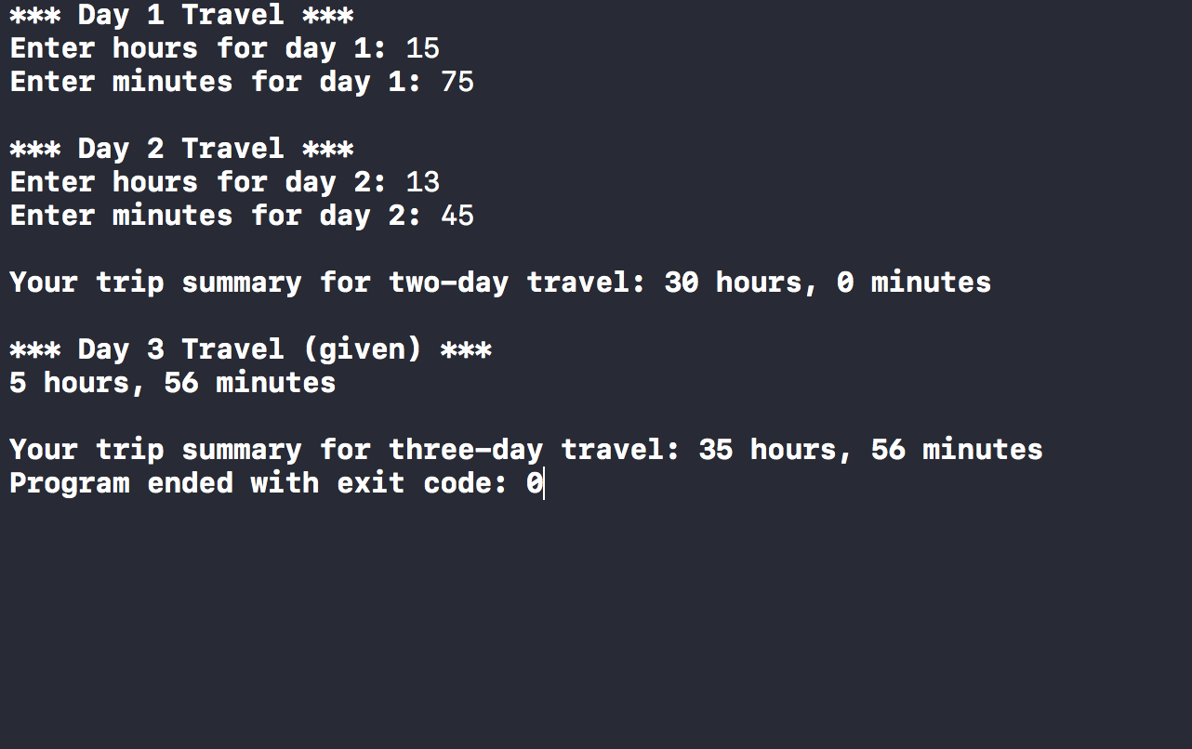

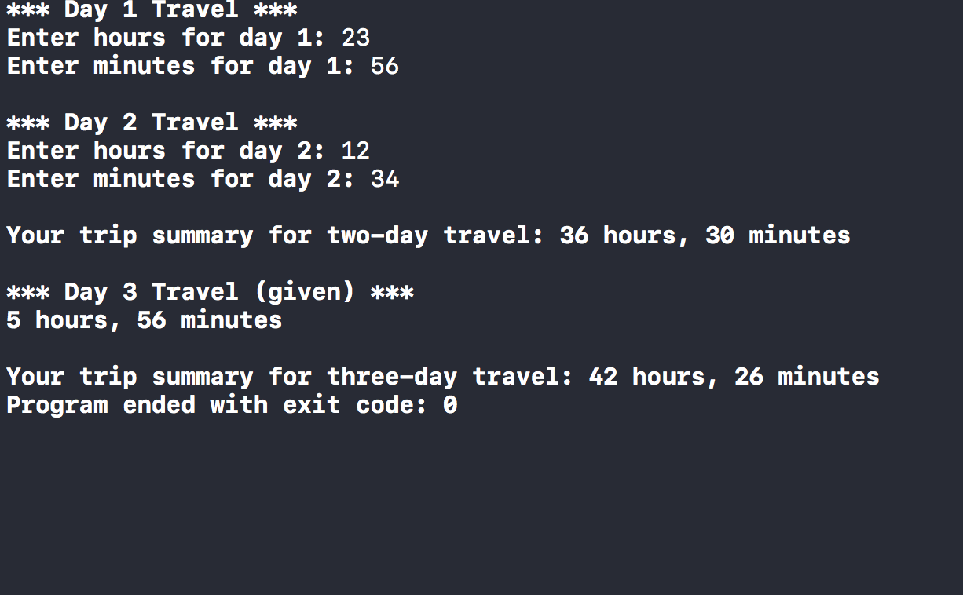

**2. CDAccount.cpp**

Write a program that creates a structure named CDAccount. The program calculates the new balance after the user inputting balance, interestRate and term.

// struct CDAccount stores balance, interestRate and term

**struct CDAccount**

**{**

**double balance;**

**double interestRate;**

**int term; //months until maturity**

**};**

// Function prototype - getData to prompt the user for inputting balance, interestRate and term.

void getData(CDAccount& Account);

**Sample Output**

Enter account balance: $1500

Enter account interest rate: 2.5

Enter the number of months until maturity

(must be 12 or fewer months): 18

When your CD matures in 18 months,

it will have a balance of $1556.25

**Copy and paste your program (source) code and the outputs after this line**

**+++++++++++++++++++++++++++++++++++++++++++++++++**

/*

CDAccount.cpp

Inola Cohen

CSIT 839 - 26953

Purpose: to create a structure named CDAccount.

to calculate the new balance after user inputs

balance. interestRate and term

*/

//#include “stdafx.h”

#include <iostream>

#include <iomanip>

using namespace std;

// structure CDACCOUNT stores balance, interest rate, and term

struct CDAccount

{

double balance;

double interestRate;

double term; // months until maturity

};

/* Function prototype */

void getData (CDAccount& Account); // prompt user to input balance, interastRate, and term

int main( )

{

double totalBalance, term;

CDAccount Account;

getData(Account);

Account.interestRate = Account.interestRate / 100;

term = Account.term / 12;

totalBalance = (1 + (term)*(Account.interestRate)) * Account.balance;

cout << "\nWhen your CD matures in " << Account.term << " months,\nit will have a balance of $" << totalBalance << endl << endl;

return 0;

}

void getData(CDAccount& Account)

{

cout << "Enter account balance: ";

cin >> Account.balance;

cout << "Enter account interest rate: ";

cin >> Account.interestRate;

cout << "Enter the number of months until maturity (must be 12 or fewer months): ";

cin >> Account.term;

while (Account.term > 12)

{

cout << "Please enter number of months that is 12 or less: ";

cin >> Account.term;

}

}

